Inventory management

Inventory management is a system of stock level control. In nopCommerce, it consists of setting up the inventory and tracking low stocks.

To set up inventory, go to **Catalog → Products → Edit a product**. In the *Edit product details* window, go to the *Inventory* panel. In this panel, you can choose one of the three inventory methods:

1. [Don't track inventory](https://docs.nopcommerce.com/en/running-your-store/order-management/inventory-management.html#dont-track-inventory)
2. [Track inventory](https://docs.nopcommerce.com/en/running-your-store/order-management/inventory-management.html#track-inventory)
3. [Track inventory by product attributes](https://docs.nopcommerce.com/en/running-your-store/order-management/inventory-management.html#track-inventory-by-product-attributes)

In the next sections, we will see the difference between these methods.

Don't track inventory

Some products might not require inventory tracking. For example, services, second hand or custom-made goods. In this case, a store owner can opt for no tracking by choosing the *Don't track inventory* option in the **Inventory method** field. 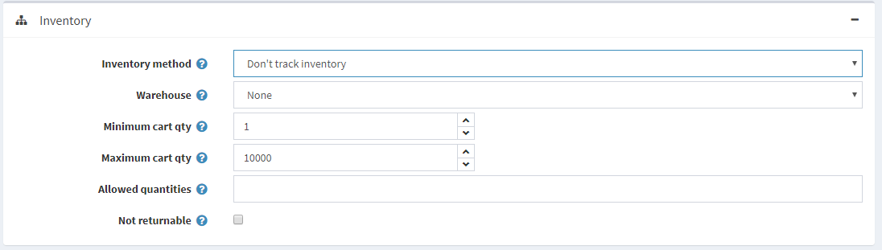

In this case, the store owner can define:

* **Warehouse** that will be used when calculating shipping rates. Read more in the [Warehouses](https://docs.nopcommerce.com/en/getting-started/configure-shipping/advanced-configuration/warehouses.html) chapter.
* **Minimum cart qty** is a quantity allowed in a customer's shopping cart, for example, set to 3 to only allow customers to purchase 3 or more items of this product.
* **Maximum cart qty** is a quantity allowed in a customer's shopping cart, for example, set to 5 to only allow customers to purchase 5 or fewer items of this product.
* In the **Allowed quantities** field, enter a comma-separated list of quantities you want this product to be restricted to. Instead of a quantity textbox that allows them to enter any quantity, they will receive a dropdown list of the values you enter here.
* Select the **Not returnable** checkbox if this product is not returnable. In this case, a customer won't be allowed to submit a return request.

Track inventory

In case inventory tracking is required, the shop owner can select an **Inventory method** between two options: *Track inventory* (by product) or *Track inventory by product attributes*. The *Track inventory* option is for those who don't have product variants and simply need to know how many items are left. In this section, we will describe the *Track inventory* option. Once this option is chosen, the section expands, displaying new fields:

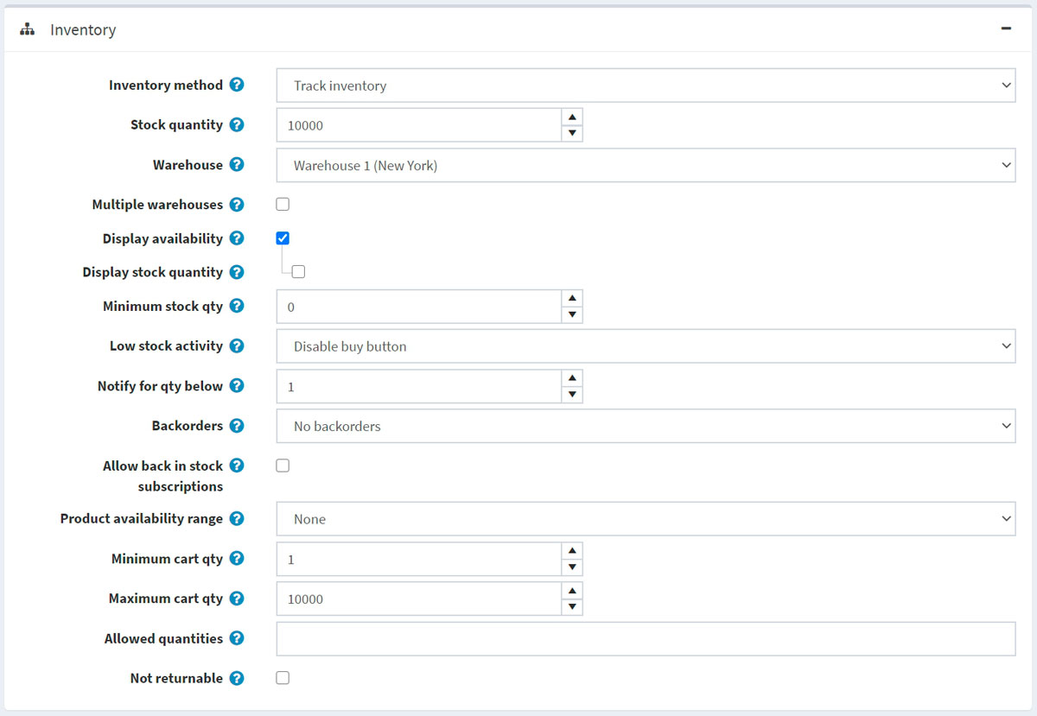

Set up inventory as follows:

* **Stock quantity** is the total quantity. It is reduced whenever an order is shipped.
* Choose the **Warehouse** that will be used when calculating shipping rates. You can manage warehouses on the **Configuration → Shipping → Warehouses** page. For further details, refer to the [Warehouses](https://docs.nopcommerce.com/en/getting-started/configure-shipping/advanced-configuration/warehouses.html) page.
* Select the **Multiple warehouses** checkbox if you want to support shipping and inventory management from multiple warehouses. This way, you can manage inventory per warehouse: 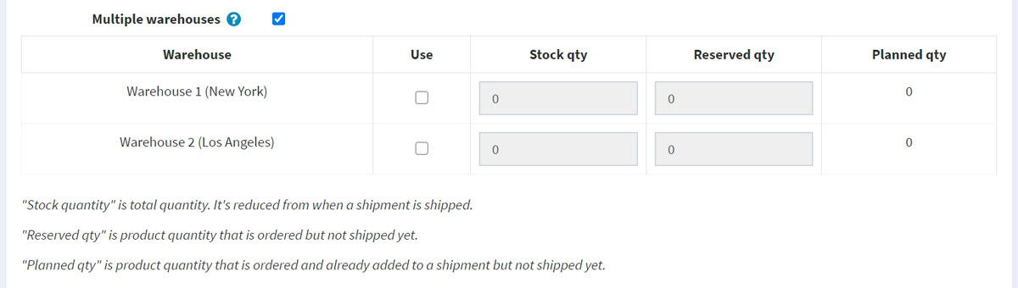 Click **Use** in the appropriate row if you want to use this warehouse for the product.
  + Enter the **Stock qty**, which is the total quantity. It is reduced whenever an order is shipped.
  + Enter the **Reserved qty**, which is the product quantity that is ordered but not shipped or added to a shipment yet.
  + The **Planned qty** is the product quantity that is ordered and already added to a shipment but not shipped yet.
* To prevent customers from placing orders and then finding out that the product is out of stock, you can take certain actions. Select the **Display availability** checkbox to display stock availability in the public store.
  + If required, select the **Display stock quantity** checkbox to enable customers to see a product stock quantity on the product details page (this checkbox is only displayed when the **Display availability** checkbox is selected). The following screenshot demonstrates what a customer will see in the public store:

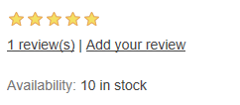

* In the **Minimum stock qty** field, enter the minimum value below which further actions will be taken.
* From the **Low stock activity** dropdown list, select the action to be taken when the stock quantity falls below the minimum stock quantity value, as follows:
  + **Nothing**: store owners can still choose to take no action. It means that customers can continue to order products.
  + **Disable buy button**: the buy button becomes disabled when stock is low. Therefore, customers cannot buy this product but can still see it existing in the store.
  + **Unpublish**: the product is not visible in the store anymore. Used when the product is going to be stopped entirely.
* In the **Notify for qty below** field, enter the value below which a notification email will be sent to the administrator.
* Store owners can set up **Backorders**, that is, orders that can not be fulfilled at the moment of purchase. From the backorders dropdown list, select the required backorder mode as follows:
  + **No backorders**: customers can't purchase this product when there is no stock available.
  + **Allow qty below 0**: customers can purchase this product even when there is no stock available.
  + **Allow qty below 0 and notify customer**: customers can purchase this product even when there is no stock available. In addition, they get a notification with the following message: *Out of stock - on backorder and will be dispatched once in stock (****Display availability****option should also be enabled in this case)*.
* Select **Allow back in stock subscriptions**, to enable customers to subscribe for notifications about product availability, as on the screenshot below:

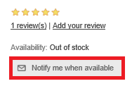

* Choose the **Product availability range** that will be displayed for customers when the product is not available at the moment. You can set up availability ranges in the *Product availability ranges* panel of the **Configuration → Shipping → Dates and ranges** page. For further details, refer to the [Dates and ranges](https://docs.nopcommerce.com/en/getting-started/configure-shipping/advanced-configuration/dates-and-ranges.html) page.
* **Minimum cart qty** is a quantity allowed in a customer's shopping cart, for example, set to 3 to only allow customers to purchase 3 or more items of this product.
* **Maximum cart qty** is a quantity allowed in a customer's shopping cart, for example, set to 5 to only allow customers to purchase 5 or fewer items of this product.
* In the **Allowed quantities** field, enter a comma-separated list of quantities you want this product to be restricted to. Instead of a quantity textbox that allows them to enter any quantity, they will receive a dropdown list of the values you enter here.
* Select the **Not returnable** checkbox if this product is not returnable. In this case, a customer won't be allowed to submit a return request.

Track inventory by product attributes

In the case you have various product attribute combinations and need to track their stock quantity, select the *Track inventory by product attributes* inventory method. Once this option is chosen, the section expands, displaying new fields:

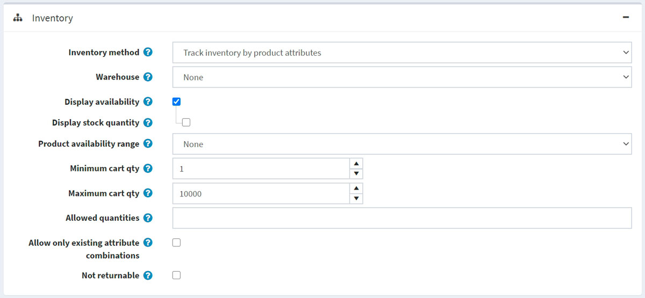

* Choose the **Warehouse** that will be used when calculating shipping rates. You can manage warehouses on the **Configuration → Shipping → Warehouses** page. For further details, refer to the [Warehouses](https://docs.nopcommerce.com/en/getting-started/configure-shipping/advanced-configuration/warehouses.html) page.
* To prevent customers from placing orders and then finding out that the product is out of stock, you can take certain actions. Select the **Display availability** checkbox to display stock availability in the public store.
  + If required, select the **Display stock quantity** checkbox to enable customers to see a product stock quantity on the product details page (this checkbox is only displayed when the **Display availability** checkbox is selected). The following screenshot demonstrates what a customer will see in the public store:



* Choose the **Product availability range** that will be displayed for customers when the product is not available at the moment. You can set up availability ranges in the *Product availability ranges* panel of the **Configuration → Shipping → Dates and ranges** page. For further details, refer to the [Dates and ranges](https://docs.nopcommerce.com/en/getting-started/configure-shipping/advanced-configuration/dates-and-ranges.html) page.
* **Minimum cart qty** is a quantity allowed in a customer's shopping cart, for example, set to 3 to only allow customers to purchase 3 or more of items this product.
* **Maximum cart qty** is a quantity allowed in a customer's shopping cart, for example, set to 5 to only allow customers to purchase 5 or fewer items of this product.
* In the **Allowed quantities** field, enter a comma-separated list of quantities you want this product to be restricted to. Instead of a quantity textbox that allows them to enter any quantity, they will receive a dropdown list of the values you enter here.
* Select **Allow only existing attribute combinations** to only allow adding to the cart/wishlist existing attribute combinations with stock quantities greater than 0. In this case, you have to create all product attribute combinations that you have in stock.
* Select the **Not returnable** checkbox if this product is not returnable. In this case, a customer won't be allowed to submit a return request.

**NOTE**

To set **Stock quantity** for different attribute combinations, go to the **Attribute combinations** tab of the *Product attributes* panel on the edit product details page. In this tab, you can define whether to **Allow out of stock** for a certain attribute combination to enable orders to be approved even when the product is out of stock. 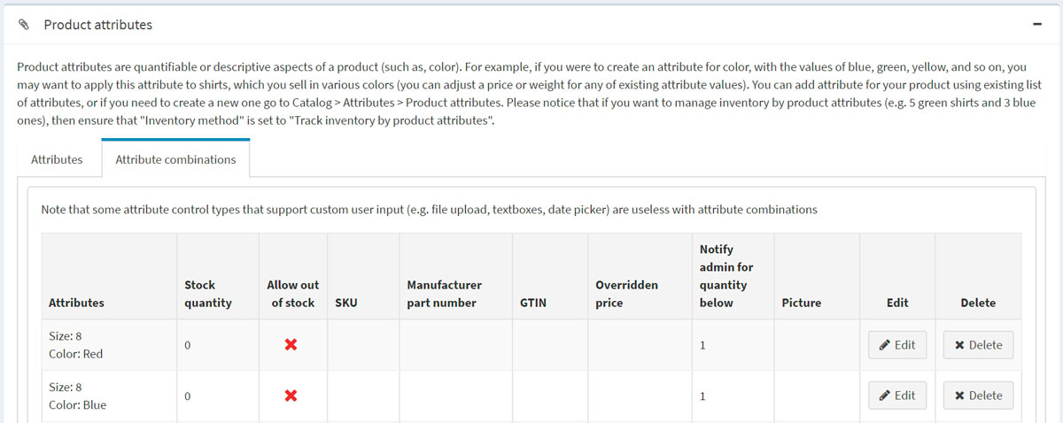

**TIP**

To track products currently under stock, go to **Reports → Low stock**. A low stock report contains a list of products that are currently under stock, that is, the stock quantity is equal to or less than the minimum stock quantity set in the *Inventory* section on the product details page. 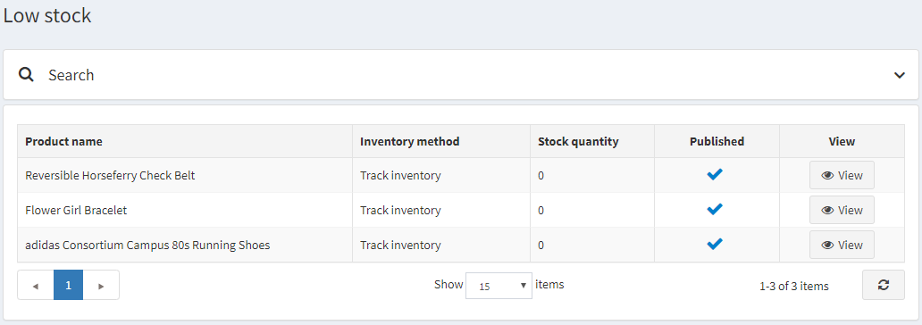 Click **View** to view the product details page, where these stock settings can be changed. For more details about reports in nopCommerce, visit the [Reports](https://docs.nopcommerce.com/en/running-your-store/reports.html) page.